|  |
| --- |
| **National University of Computer and Emerging Sciences** |
| Inlab  “Triggers” |
|  |
| Database Systems |
| Spring 2018 |

Department of Computer Science

FAST-NU, Lahore, Pakistan

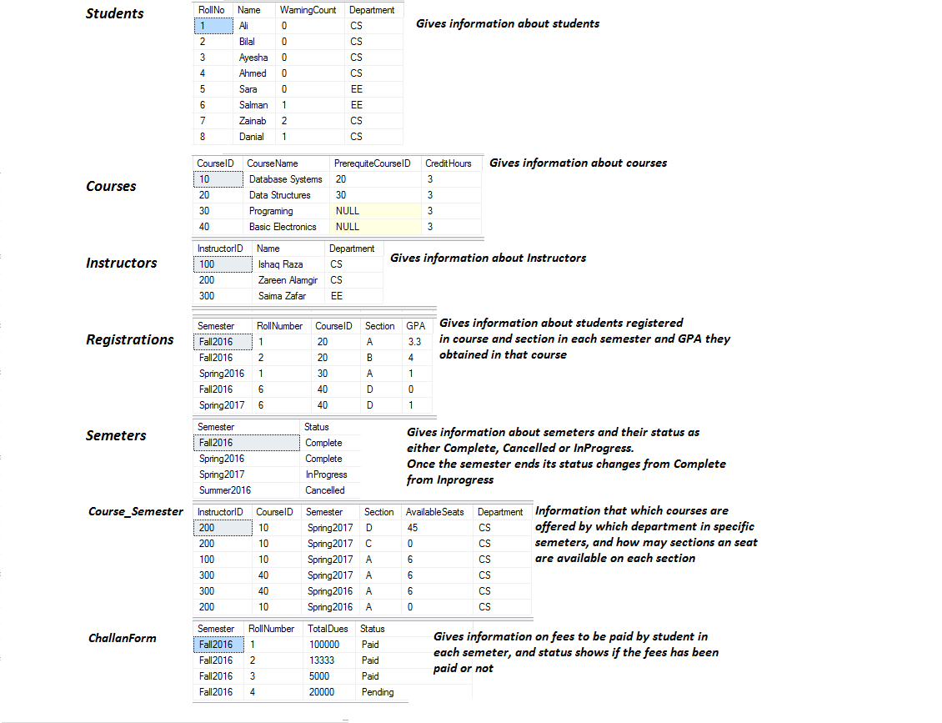

This is a caricature of Neon Schema. A student can only register courses in any semester whose status is InProcess. The GPA for all InProcess semester courses will be -1.

**Functionality 1:**

Create a new table, ‘Notify’ that should notify students about any important events. The table has three columns, NotifictionID, StudentID and Notification String. Create a Trigger to notify student if his registration in the course is successful. Also inform user if registration is not successful.

**Functionality 2:**

According to university rules, Students before enrolling in new course should have no fee charges due. Create a trigger to ensure that no student is enrolled in new course with more than 20,000 fee charges due.

**Functionality 3:**

Create a trigger that do not let you delete any course semester whose available seats are less than 10. Print ‘not possible’.

Also create a trigger that prints ‘Successfully deleted’, after you delete any course semester whose available seats are 10 or more.

**Functionality 4:**

Create a trigger to stop Instructors table, from being modified of dropped.